**A**

**Micro Project Report on**

**Women Safety App**

**Submitted by**

Siddhesh Jagdish Shelar

Jainul Jignesh Dave

Shreyash Kiran Dahale

Ojas Yogesh Joshi

**Under the Guidance of**

**Prof. N.D. Dhamale**

In the Partial Fulfilment of Fifth Semester of Diploma in Computer Engineering



**Department of Computer Engineering Sandip Polytechnic**

**Mahiravani, Nashik - 422213**

Affiliated to

**Maharashtra State Board of Technical Education**

**Academic Year 2020-21**



## Maharashtra State Board of Technical Education

**Certificate**

This is to certify that **Mr. Siddhesh Jagdish Shelar** with **Roll No-** **12** has successfully completed Micro-project in course **Mobile App Development (22617)** for the academic year 2020-21 as prescribed in the 'Assessment Manual' during his/her tenure of completing Sixth Semester of Diploma Programme in Computer Engineering from institute, Sandip Polytechnic with institute code 1167.

**Place:** Nashik **Enrollment No:** 1711670171

#### Date: //2021 Exam Seat No:

**Course Teacher Head of the Department Head of the Institute**

**Annexure – I**

**Micro Project Proposal**

**1.0 Aims/Benefits of the Micro-Project:**

This system is for women’s safety and overcomes existing systems. This GPS system is the “Women’s Safety App”. It consists of a GPS device, an Android phone. The unit will provide status information such as latitude, the longitude of the user.

The proposed App is based on advanced sensors. Each time a user makes a phone call, an emergency signal will be generated automatically and then an information alert will be sent to the contacts that have been added to the emergency call.

The proposed system will be implemented with the help of android application. Which will alert the nearby people who having this application by sending alert messages to them and alert sound in the guardian mobile on shaking of victim mobile. Also sends messages and alert sound to the saved contacts in the application and police station. Which also show the location of the victim with the help of GPS tracker system. Which also make sound in guardian mobile when his/her mobile in silent mode.

### 2.0 Course Outcomes Addressed:

* + 1. Interprete features of Andriod operating system.
    2. Configure Android environment and development tools.
    3. Develop rich users Interfaces by using layouts and controls.
    4. Use User Interface components for android application development.
    5. Create Android application using database.
    6. Publish Android applications.

### 3.0 Proposed Methodology:

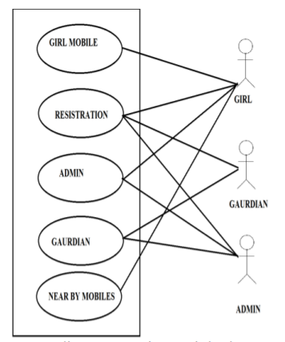

A Use case is a description of set of sequence of actions graphically it is rendered as an ellipse with solid line including only its name. Use case diagram is a behavioural diagram that shows a set of use cases and actors and their relationship. It is an association between the use cases and actors. An actor represents a real-world object.

**Use case diagram consists mainly three modules :**

* Guardian app which is installed in the guardian mobile. and initiated by giving there mobile number
* . Girl app which is installed in the girls mobile. and initiated by giving girls name, id, mobile number.
* Server login module which consists data of guardian location information

**4.0 Action Plan:**

|  |  |  |  |  |
| --- | --- | --- | --- | --- |
| **Sr No** | **Details of Activity** | **Planned Start Date** | **Planned Finish Date** | **Name of Responsible Team Members** |
| 1 | Topic Discussion & Selection | 11/12/1018 | 15/12/2018 | * + Siddhesh Jagdish Shelar   + Jainul Jignesh Dave   + Shreyash Kiran Dahale   + Ojas Yogesh Joshi |
| 2 | Review of Literature | 17/12/2018 | 22/12/2018 |
| 3 | Aim/Benefits & Importance | 24/12/2018 | 29/12/2018 |
| 4 | Resources Required | 31/12/2018 | 05/01/2019 |
| 5 | Analysis of Collected Data | 07/01/2019 | 12/01/2019 |
| 6 | Design of System | 14/01/2019 | 19/01/2019 |
| 7 | Coding & Testing of Modules | 21/01/2019 | 25/01/2019 |
| 8 | Coding & Testing of Modules | 28/01/2019 | 02/02/2019 |
| 9 | Coding & Testing of Modules | 04/02/2019 | 09/02/2019 |
| 10 | Integration of System Modules | 11/02/2019 | 16/02/2019 |
| 11 | Testing & Deployment of System | 18/02/2019 | 23/02/2019 |
| 12 | Compilation of Report | 25/02/2019 | 02/03/2019 |
| 13 | Compilation of Presentation | 05/03/2019 | 09/03/2019 |
| 14 | Presentation of Seminar | 11/03/2019 | 16/03/2019 |
| 15 | Final Deployment of Submission | 18/03/2019 | 20/03/2019 |

**5.0 Resources required:**

|  |  |  |  |  |
| --- | --- | --- | --- | --- |
| **Sr No** | **Name of Resource/Material** | **Specification** | **Qty.** | **Remarks** |
| 1 | Hardware Resource | Desktop with Intel Core 2 Duo  2.93 GHz, RAM 2GB, HDD 160 GB | 1 | **-** |
| 2 | Software Resource | Android Studio | 1 | **-** |
| 3 | Any Other Resource | Internet | - | **-** |

**Name of Team Members with Roll Nos:**

|  |  |
| --- | --- |
| **Roll No** | **Name of Team Members** |
| 12 | Siddhesh Jagdish Shelar |
| 01 | Jainul Jignesh Dave |
| 08 | Shreyash Kiran Dahale |
| 57 | Ojas Yogesh Joshi |

**Name & Signature of Course Teacher**

**(Prof. B.S. CHAUDHARY)**

#### Annexure – I

# Micro Project Report

1. **Rationale:**

In today’s fast moving world, Women Security is an issue of growing concern. We have read about many unfortunate incidents happening with women and the rate is increasing. Women these days are working women and the globalization has made us aware of gender equality. Earlier the women were restricted only to the household chores. With the changing scenario, women are competing with men in all fields .We can see women going to great success levels in all fields, may it be corporate, scientific, education, business or any other field. Safety of women matters a lot whether at home, outside the home or working place. Last few crimes against women especially the case in Delhi was very dread and fearful. Because of such crimes, women safety has become a major topic. According to the statistics, it is found that every two out of three women have suffered trauma in the last year. According to the survey of women, it is found that women are losing their confidence because of such incidents. By the survey of Delhi government’s Women and Child Development Department, around 80% of the women in national capital have fear regarding their safety. Women are harassed not only in the night or evening but also in the day time at their home, working places, or other places like street, club, etc. It is found through the survey that the reason of safety concern is the lack of gender-friendly environment and improper functional infrastructure such as consumption of alcohol and drugs in open area, lack of adequate lighting, safe public toilets, sidewalks, lack of effective police service, lack of properly working helpline numbers, etc. A huge percentage of women have no faith that police can curb such harassment cases. There is an urgent need to understand and solve this problem of women safety so that they can also grow equally like men in their own country.

**Aims/Benefits of the Micro-Project:**

In today’s world, people using smart phones have increased rapidly and hence, a smart phone can be used efficiently for personal security or various other protection purposes. The heinous incident that outraged the entire nation have waken us to go for the safety issues and so a host of new apps have been developed to provide security systems to women via their phones. This paper presents women security an Android Application for the Safety of Women and this app can be activated this app by a shaking the mobile, whenever need arises. This app identifies the location of place through GPS and sends a message comprising this location URL to the registered contacts and also send messages to near by mobile which are having this app.

**The system will be implemented as a 3 module application :**

**• Victim app module**

1. Initially the victim app need to be installed in the mobile.
2. Then victim should enrol her ID, Name, Phone number.
3. And then click on register button.
4. Then it display registered successfully.
5. If that mobile number is already registered it will display this number is already registered.

**• Guardian app module**

1. Initially the guardian app need to be installed in the mobile.
2. Guardian should enroll their phone numbers.
3. And click on register button.
4. Then it display registered successfully.
5. If that mobile number is already registered it will display this number is already registered.

**• Server module**

1. After installation of guardian app and victim app two tables are created in server model.
2. Two tables are victim table and guardian table.
3. Victim table contain five columns VID, VNAME, PHONE -NUMBER, LATITUDE, LONGITUDE.
4. Guardian table contains three columns PHONE NUMBER, LATITUDE, LONGITUDE.

### 3.0 Course Outcomes Achieved:

* + 1. Develop program using GUI framework (ATW and Swing).
    2. Handle events of AWT and swing components.
    3. Develop programs to handle events in java programming.
    4. Develop java programs using networking concepts.
    5. Develop program using database.
    6. Develop programs using servlets.

### 4.0 Actual Methodology Followed:

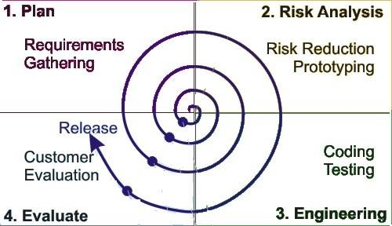

#### Figure : Spiral Model of Software Development

Figure shows the spiral model of software development. This model is combination of well- known waterfall model and iterative prototyping. It yields rapid development of more complete version of software. Using spiral model software is developed as series of

Evolutionary releases. During the initial releases, it may just paperwork or prototype. But during later releases the version goes towards more completed stage.

The spiral model can be adopted to apply throughout entire lifecycle of the application from concept development to maintenance. The spiral model is divided into set of framework activities defined by software engineer team. The initial activity is shown from center of circle and developed in clockwise direction. Each spiral of the model includes following four stages:

Planning Phase: This stage includes requirement gathering, cost estimation, resource allocation. Risk Analysis Phase: This stage involves strengths and weaknesses of the project. Design Phase: This stage includes coding, internal testing and deployment.

Evaluation Phase: Last stage involves client evaluation (client side testing) to get the feedback. Various activities which are performed according to the spiral model phases are shownTab.

**5.0 Actual Resources Used:**

|  |  |  |  |  |
| --- | --- | --- | --- | --- |
| **Sr No** | **Name of Resource/Material** | **Specification** | **Qty.** | **Remarks** |
| 1 | Hardware Resource | Processor i3/HDD-  1TB/RAM-8GB | 1 |  |
| 2 | Software Resource | Android Studio,  jdk1.8.0 | 1 |  |
| 3 | Any Other Resource | Printer | 1 |  |

**Code:**

**//XML CODE**

1. **Home Page**

<RelativeLayout xmlns:android="http://schemas.android.com/apk/res/android"

xmlns:tools="http://schemas.android.com/tools"

android:layout_width="match_parent"

android:layout_height="match_parent"

android:paddingBottom="@dimen/activity_vertical_margin"

android:paddingLeft="@dimen/activity_horizontal_margin"

android:paddingRight="@dimen/activity_horizontal_margin"

android:paddingTop="@dimen/activity_vertical_margin"

tools:context=".MainActivity" >

<Button

android:id="@+id/button1"

android:layout_width="fill_parent"

android:layout_height="wrap_content"

android:layout_above="@+id/button2"

android:layout_alignLeft="@+id/button2"

android:onClick="register"

android:layout_marginBottom="71dp"

android:text="Register" />

<Button

android:id="@+id/button3"

android:layout_width="fill_parent"

android:layout_height="wrap_content"

android:layout_alignLeft="@+id/button2"

android:layout_below="@+id/button2"

android:onClick="display_no"

android:layout_marginTop="74dp"

android:text="View Registered" />

<Button

android:id="@+id/button2"

android:layout_width="fill_parent"

android:layout_height="wrap_content"

android:layout_centerHorizontal="true"

android:onClick="instruct"

android:layout_centerVertical="true"

android:text="Instructions" />

<Button

android:id="@+id/button4"

android:layout_width="match_parent"

android:layout_height="wrap_content"

android:layout_alignParentBottom="true"

android:layout_centerHorizontal="true"

android:onClick="verify"

android:text="Register Your Mobile Number" />

</RelativeLayout>

1. **Register:**

<RelativeLayout xmlns:android="http://schemas.android.com/apk/res/android"

xmlns:tools="http://schemas.android.com/tools"

android:layout_width="match_parent"

android:layout_height="match_parent"

android:paddingBottom="@dimen/activity_vertical_margin"

android:paddingLeft="@dimen/activity_horizontal_margin"

android:paddingRight="@dimen/activity_horizontal_margin"

android:paddingTop="@dimen/activity_vertical_margin"

tools:context=".Register" >

<TextView

android:id="@+id/textView1"

android:layout_width="wrap_content"

android:layout_height="wrap_content"

android:layout_alignParentLeft="true"

android:layout_alignParentTop="true"

android:layout_marginTop="64dp"

android:text="Name:" />

<TextView

android:id="@+id/textView2"

android:layout_width="wrap_content"

android:layout_height="wrap_content"

android:layout_alignLeft="@+id/textView1"

android:layout_below="@+id/textView1"

android:layout_marginTop="71dp"

android:text="Number:" />

<Button

android:id="@+id/button1"

android:layout_width="match_parent"

android:layout_height="wrap_content"

android:layout_below="@+id/textView2"

android:layout_centerHorizontal="true"

android:layout_marginTop="68dp"

android:onClick="storeInDB"

android:text="Save" />

<EditText

android:id="@+id/editText2"

android:layout_width="wrap_content"

android:layout_height="wrap_content"

android:layout_alignBaseline="@+id/textView2"

android:layout_alignBottom="@+id/textView2"

android:layout_alignRight="@+id/button1"

android:ems="10"

android:hint="Mobile Number"

android:inputType="phone" />

<EditText

android:id="@+id/editText1"

android:layout_width="wrap_content"

android:layout_height="wrap_content"

android:layout_alignBaseline="@+id/textView1"

android:layout_alignBottom="@+id/textView1"

android:layout_alignLeft="@+id/editText2"

android:ems="10"

android:hint="Person Name"

android:inputType="textPersonName" >

<requestFocus />

</EditText>

<Button

android:id="@+id/button2"

style="?android:attr/buttonStyleSmall"

android:layout_width="wrap_content"

android:layout_height="wrap_content"

android:layout_alignLeft="@+id/button1"

android:layout_alignParentBottom="true"

android:layout_marginBottom="21dp"

android:onClick="instructions"

android:text="Instructions" />

<Button

android:id="@+id/button3"

style="?android:attr/buttonStyleSmall"

android:layout_width="wrap_content"

android:layout_height="wrap_content"

android:layout_alignRight="@+id/button1"

android:layout_alignTop="@+id/button2"

android:onClick="display"

android:text="View Registered" />

</RelativeLayout>

1. **Verify:**

<RelativeLayout xmlns:android="http://schemas.android.com/apk/res/android"

xmlns:tools="http://schemas.android.com/tools"

android:layout_width="match_parent"

android:layout_height="match_parent"

android:paddingBottom="@dimen/activity_vertical_margin"

android:paddingLeft="@dimen/activity_horizontal_margin"

android:paddingRight="@dimen/activity_horizontal_margin"

android:paddingTop="@dimen/activity_vertical_margin"

tools:context=".Verify" >

<Button

android:id="@+id/button1"

android:layout_width="wrap_content"

android:layout_height="wrap_content"

android:layout_alignParentBottom="true"

android:layout_centerHorizontal="true"

android:layout_marginBottom="176dp"

android:onClick="verify_no"

android:text="Submit" />

<EditText

android:id="@+id/editText1"

android:layout_width="wrap_content"

android:layout_height="wrap_content"

android:layout_above="@+id/button1"

android:layout_centerHorizontal="true"

android:layout_marginBottom="76dp"

android:ems="10"

android:hint="Your Phone Number"

android:inputType="phone" >

<requestFocus />

</EditText>

<Button

android:id="@+id/button2"

style="?android:attr/buttonStyleSmall"

android:layout_width="wrap_content"

android:layout_height="wrap_content"

android:layout_alignParentBottom="true"

android:layout_centerHorizontal="true"

android:layout_marginBottom="94dp"

android:onClick="back"

android:text="Back" />

</RelativeLayout>

1. **Instructions:**

<RelativeLayout xmlns:android="http://schemas.android.com/apk/res/android"

xmlns:tools="http://schemas.android.com/tools"

android:layout_width="match_parent"

android:layout_height="match_parent"

android:paddingBottom="@dimen/activity_vertical_margin"

android:paddingLeft="@dimen/activity_horizontal_margin"

android:paddingRight="@dimen/activity_horizontal_margin"

android:paddingTop="@dimen/activity_vertical_margin"

tools:context=".Instructions" >

<TextView

android:id="@+id/textView1"

android:layout_width="wrap_content"

android:layout_height="wrap_content"

android:layout_alignParentTop="true"

android:layout_centerHorizontal="true"

android:layout_marginTop="16dp"

android:text="INSTRUCTIONS"

android:textAppearance="?android:attr/textAppearanceLarge" />

<Button

android:id="@+id/button1"

android:layout_width="match_parent"

android:layout_height="wrap_content"

android:layout_below="@+id/help"

android:layout_centerHorizontal="true"

android:layout_marginTop="34dp"

android:onClick="back"

android:text="Main Menu" />

<TextView

android:id="@+id/help"

android:layout_width="wrap_content"

android:layout_height="wrap_content"

android:layout_alignLeft="@+id/button1"

android:layout_below="@+id/textView1"

android:layout_marginTop="15dp"

android:text="@string/help" />

</RelativeLayout>

1. **Display:**

<RelativeLayout xmlns:android="http://schemas.android.com/apk/res/android"

xmlns:tools="http://schemas.android.com/tools"

android:layout_width="match_parent"

android:layout_height="match_parent"

android:paddingBottom="@dimen/activity_vertical_margin"

android:paddingLeft="@dimen/activity_horizontal_margin"

android:paddingRight="@dimen/activity_horizontal_margin"

android:paddingTop="@dimen/activity_vertical_margin"

tools:context=".Display" >

<TextView

android:layout_width="wrap_content"

android:layout_height="wrap_content"

android:layout_centerHorizontal="true"

android:text="Shake your phone to TEST." />

<Button

android:id="@+id/button1"

android:layout_width="match_parent"

android:layout_height="wrap_content"

android:layout_alignParentBottom="true"

android:layout_centerHorizontal="true"

android:onClick="back"

android:text="Main Menu" />

</RelativeLayout>

**//JAVA CODE**

1. **AccelerometerManager.java**

package com.sid.womensafetyapp;

import java.util.List;

import android.content.Context;

import android.hardware.Sensor;

import android.hardware.SensorEvent;

import android.hardware.SensorEventListener;

import android.hardware.SensorManager;

import android.widget.Toast;

public class AccelerometerManager {

private static Context aContext=null;

/** Accuracy configuration */

private static float threshold = 15.0f;

private static int interval = 200;

private static Sensor sensor;

private static SensorManager sensorManager;

// you could use an OrientationListener array instead

// if you plans to use more than one listener

private static AccelerometerListener listener;

/** indicates whether or not Accelerometer Sensor is supported */

private static Boolean supported;

/** indicates whether or not Accelerometer Sensor is running */

private static boolean running = false;

/**

* Returns true if the manager is listening to orientation changes

*/

public static boolean isListening() {

return running;

}

/**

* Unregisters listeners

*/

public static void stopListening() {

running = false;

try {

if (sensorManager != null && sensorEventListener != null) {

sensorManager.unregisterListener(sensorEventListener);

}

} catch (Exception e) {}

}

/**

* Returns true if at least one Accelerometer sensor is available

*/

public static boolean isSupported(Context context) {

aContext = context;

if (supported == null) {

if (aContext != null) {

sensorManager = (SensorManager) aContext.

getSystemService(Context.SENSOR_SERVICE);

// Get all sensors in device

List<Sensor> sensors = sensorManager.getSensorList(

Sensor.TYPE_ACCELEROMETER);

supported = new Boolean(sensors.size() > 0);

} else {

supported = Boolean.FALSE;

}

}

return supported;

}

1. **BgService.java**

package com.sid.womensafetyapp;

import android.annotation.SuppressLint;

import android.app.Service;

import android.content.Context;

import android.content.Intent;

import android.database.Cursor;

import android.database.sqlite.SQLiteDatabase;

import android.os.Bundle;

import android.os.Handler;

import android.os.HandlerThread;

import android.os.IBinder;

import android.os.Looper;

import android.os.Message;

import android.telephony.SmsManager;

import android.util.Log;

import android.widget.Toast;

@SuppressLint("HandlerLeak")

public class BgService extends Service implements AccelerometerListener{

String str_address;

private Looper mServiceLooper;

private ServiceHandler mServiceHandler;

// Handler that receives messages from the thread.

private final class ServiceHandler extends Handler {

public ServiceHandler(Looper looper) {

super(looper);

}

@Override

public void handleMessage(Message msg) {

// REPLACE THIS CODE WITH YOUR APP CODE

// Wait before Toasting Service Message

// to give the Service Started message time to display.

// Toast Service Message.

/* Context context = getApplicationContext();

CharSequence text = "Service Message";

int duration = Toast.LENGTH_LONG;

Toast toast = Toast.makeText(context, text, duration);

toast.show();

*/

// Service can stop itself using the stopSelf() method.

// Not using in this app. Example statement shown below.

//stopSelf(msg.arg1);

}

}

@Override

public IBinder onBind(Intent arg0) {

return null;

}

@Override

public void onCreate() {

super.onCreate();

if (AccelerometerManager.isSupported(this)) {

AccelerometerManager.startListening(this);

}

HandlerThread thread = new HandlerThread("ServiceStartArguments",android.os.Process.THREAD_PRIORITY_BACKGROUND);

thread.start();

mServiceLooper = thread.getLooper();

mServiceHandler = new ServiceHandler(mServiceLooper);

}

@Override

public int onStartCommand(Intent intent, int flags, int startId) {

// Get message from message pool using handler.

Message msg = mServiceHandler.obtainMessage();

// Set start ID (unique to the specific start) in message.

msg.arg1 = startId;

// Send message to start job.

mServiceHandler.sendMessage(msg);

// Toast Service Started message.

// Context context = getApplicationContext();

/* CharSequence text = "Service Started";

int duration = Toast.LENGTH_SHORT;

Toast toast = Toast.makeText(context, text, duration);

toast.show();

*/

// Start a sticky.

return START_STICKY;

}

public class GeocoderHandler extends Handler {

@Override

public void handleMessage(Message message) {

Toast.makeText(getApplicationContext(), "geocoderhandler started", Toast.LENGTH_SHORT).show();

switch (message.what) {

case 1:

Bundle bundle = message.getData();

str_address = bundle.getString("address");

// TelephonyManager tmgr=(TelephonyManager)BgService.this.getSystemService(Context.TELEPHONY_SERVICE);

// String ph_number=tmgr.getLine1Number();

SQLiteDatabase db;

db=openOrCreateDatabase("NumDB", Context.MODE_PRIVATE, null);

Cursor c=db.rawQuery("SELECT * FROM details", null);

Cursor c1=db.rawQuery("SELECT * FROM SOURCE", null);

String source_ph_number=c1.getString(0);

while(c.moveToNext())

{

String target_ph_number=c.getString(1);

// SmsManager smsManager=SmsManager.getDefault();

// smsManager.sendTextMessage("+918121668944", "+918121668944", "Please help me. I need help immediately. This is where i am now:"+str_address, null, null);

Toast.makeText(getApplicationContext(), "Source:"+source_ph_number+"Target:"+target_ph_number, Toast.LENGTH_SHORT).show();

}

db.close();

break;

default:

str_address = null;

}

Toast.makeText(getApplicationContext(), str_address, Toast.LENGTH_SHORT).show();

}

}

@Override

public void onAccelerationChanged(float x, float y, float z) {

// TODO Auto-generated method stub

}

@Override

public void onShake(float force) {

GPSTracker gps;

gps = new GPSTracker(BgService.this);

if(gps.canGetLocation()){

double latitude = gps.getLatitude();

double longitude = gps.getLongitude();

RGeocoder RGeocoder = new RGeocoder();

RGeocoder.getAddressFromLocation(latitude, longitude,getApplicationContext(), new GeocoderHandler());

Toast.makeText(getApplicationContext(), "onShake", Toast.LENGTH_SHORT).show();

}

else{

gps.showSettingsAlert();

}

}

// onDestroy method. Display toast that service has stopped.

@Override

public void onDestroy() {

super.onDestroy();

// Toast Service Stopped.

Context context = getApplicationContext();

Log.i("Sensor", "Service distroy");

if (AccelerometerManager.isListening()) {

AccelerometerManager.stopListening();

}

CharSequence text = "Women Safety App Service Stopped";

int duration = Toast.LENGTH_SHORT;

Toast toast = Toast.makeText(context, text, duration);

toast.show();

}

}

1. **Verify.java**

package com.sid.womensafetyapp;

import android.os.Bundle;

import android.app.Activity;

import android.view.Menu;

import android.view.MenuItem;

import android.view.View;

import android.widget.EditText;

import android.widget.Toast;

import android.support.v4.app.NavUtils;

import android.annotation.TargetApi;

import android.content.Context;

import android.content.Intent;

import android.database.sqlite.SQLiteDatabase;

import android.os.Build;

public class Verify extends Activity {

@Override

protected void onCreate(Bundle savedInstanceState) {

super.onCreate(savedInstanceState);

setContentView(R.layout.activity_verify);

// Show the Up button in the action bar.

setupActionBar();

}

public void verify_no(View v) {

EditText source_no = (EditText) this.findViewById(R.id.editText1);

String str_source_no=source_no.getText().toString();

SQLiteDatabase db;

db=openOrCreateDatabase("NumDB", Context.MODE_PRIVATE, null);

// if(source_no.getText()!=null){

db.execSQL("CREATE TABLE IF NOT EXISTS source(number VARCHAR);");

db.execSQL("INSERT INTO source VALUES('"+str_source_no+"');");

Toast.makeText(getApplicationContext(), str_source_no+" Successfully Saved",Toast.LENGTH_SHORT).show();

db.close();

back(v);

// }

// else{

// Toast.makeText(getApplicationContext(), "Enter Your Number.",Toast.LENGTH_SHORT).show();

// }

}

/**

* Set up the {@link android.app.ActionBar}, if the API is available.

*/

@TargetApi(Build.VERSION_CODES.HONEYCOMB)

private void setupActionBar() {

if (Build.VERSION.SDK_INT >= Build.VERSION_CODES.HONEYCOMB) {

getActionBar().setDisplayHomeAsUpEnabled(true);

}

}

@Override

public boolean onCreateOptionsMenu(Menu menu) {

// Inflate the menu; this adds items to the action bar if it is present.

getMenuInflater().inflate(R.menu.verify, menu);

return true;

}

@Override

public boolean onOptionsItemSelected(MenuItem item) {

switch (item.getItemId()) {

case android.R.id.home:

// This ID represents the Home or Up button. In the case of this

// activity, the Up button is shown. Use NavUtils to allow users

// to navigate up one level in the application structure. For

// more details, see the Navigation pattern on Android Design:

//

// http://developer.android.com/design/patterns/navigation.html#up-vs-back

//

NavUtils.navigateUpFromSameTask(this);

return true;

}

return super.onOptionsItemSelected(item);

}

public void back(View v) {

Intent i_back=new Intent(Verify.this,MainActivity.class);

startActivity(i_back);

}

}

1. **Display.java**

package com.sid.womensafetyapp;

import android.app.Activity;

import android.app.AlertDialog.Builder;

import android.content.Context;

import android.content.Intent;

import android.database.Cursor;

import android.database.sqlite.SQLiteDatabase;

import android.os.Bundle;

import android.view.View;

public class Display extends Activity{

Cursor c;

@Override

protected void onCreate(Bundle savedInstanceState) {

super.onCreate(savedInstanceState);

setContentView(R.layout.activity_display);

SQLiteDatabase db;

db=openOrCreateDatabase("NumDB", Context.MODE_PRIVATE, null);

c=db.rawQuery("SELECT * FROM details", null);

if(c.getCount()==0)

{

showMessage("Error", "No records found.");

return;

}

StringBuffer buffer=new StringBuffer();

while(c.moveToNext())

{

buffer.append("Name: "+c.getString(0)+"\n");

buffer.append("Number: "+c.getString(1)+"\n");

}

showMessage("Details", buffer.toString());

Intent i_startservice=new Intent(Display.this,BgService.class);

startService(i_startservice);

}

public void showMessage(String title,String message)

{

Builder builder=new Builder(this);

builder.setCancelable(true);

builder.setTitle(title);

builder.setMessage(message);

builder.show();

}

public void back(View v) {

Intent i_back=new Intent(Display.this,MainActivity.class);

startActivity(i_back);

}

}

1. **RGeocoder.java**

package com.sid.womensafetyapp;

import java.io.IOException;

import java.util.List;

import java.util.Locale;

import android.content.Context;

import android.location.Address;

import android.location.Geocoder;

import android.os.Bundle;

import android.os.Handler;

import android.os.Message;

import android.util.Log;

public class RGeocoder {

private static final String TAG = "LocationAddress";

public void getAddressFromLocation(final double latitude, final double longitude,

final Context context, final Handler handler) {

Thread thread = new Thread() {

@Override

public void run() {

Geocoder geocoder = new Geocoder(context, Locale.getDefault());

String result = null;

try {

List<Address> addressList = geocoder.getFromLocation(latitude, longitude, 1);

if (addressList != null && addressList.size() > 0) {

Address address = addressList.get(0);

StringBuilder sb = new StringBuilder();

for (int i = 0; i < address.getMaxAddressLineIndex(); i++) {

sb.append(address.getAddressLine(i)).append("\n");

}

sb.append(address.getLocality()).append("\n");

sb.append(address.getPostalCode()).append("\n");

sb.append(address.getCountryName());

result = sb.toString();

}

}

catch (IOException e) {

Log.e(TAG, "Unable connect to Geocoder", e);

}

finally {

Message message = Message.obtain();

message.setTarget(handler);

if (result != null) {

message.what = 1;

Bundle bundle = new Bundle();

result = "Latitude: " + latitude + " Longitude: " + longitude +

"\n\nAddress:\n" + result;

bundle.putString("address", result);

message.setData(bundle);

} else {

message.what = 1;

Bundle bundle = new Bundle();

result = "Latitude: " + latitude + " Longitude: " + longitude +

"\n Unable to get address for this lat-long.";

bundle.putString("address", result);

message.setData(bundle);

}

message.sendToTarget();

}

}

};

thread.start();

}

}

### Outputs: Home Page

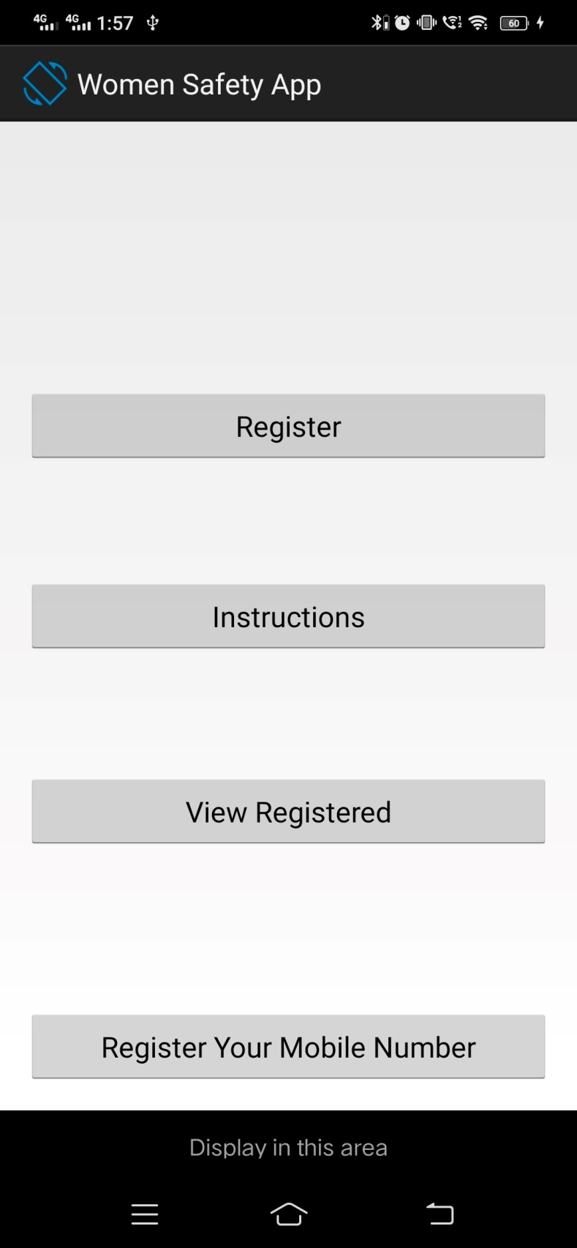

**Fig. Home**

**Register Page**

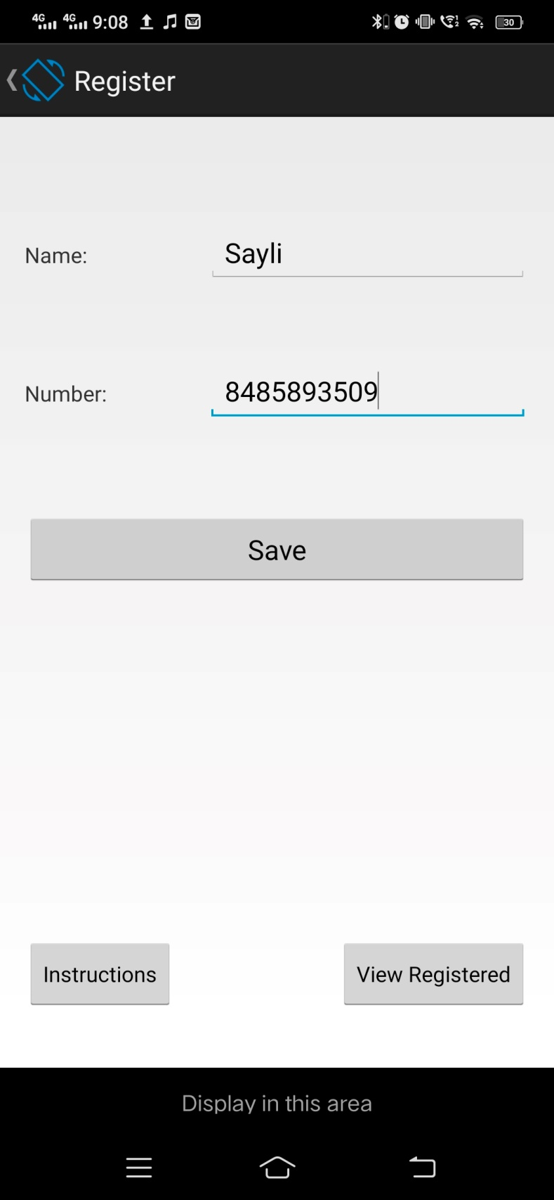

**Fig. Register**

**Verify Page**

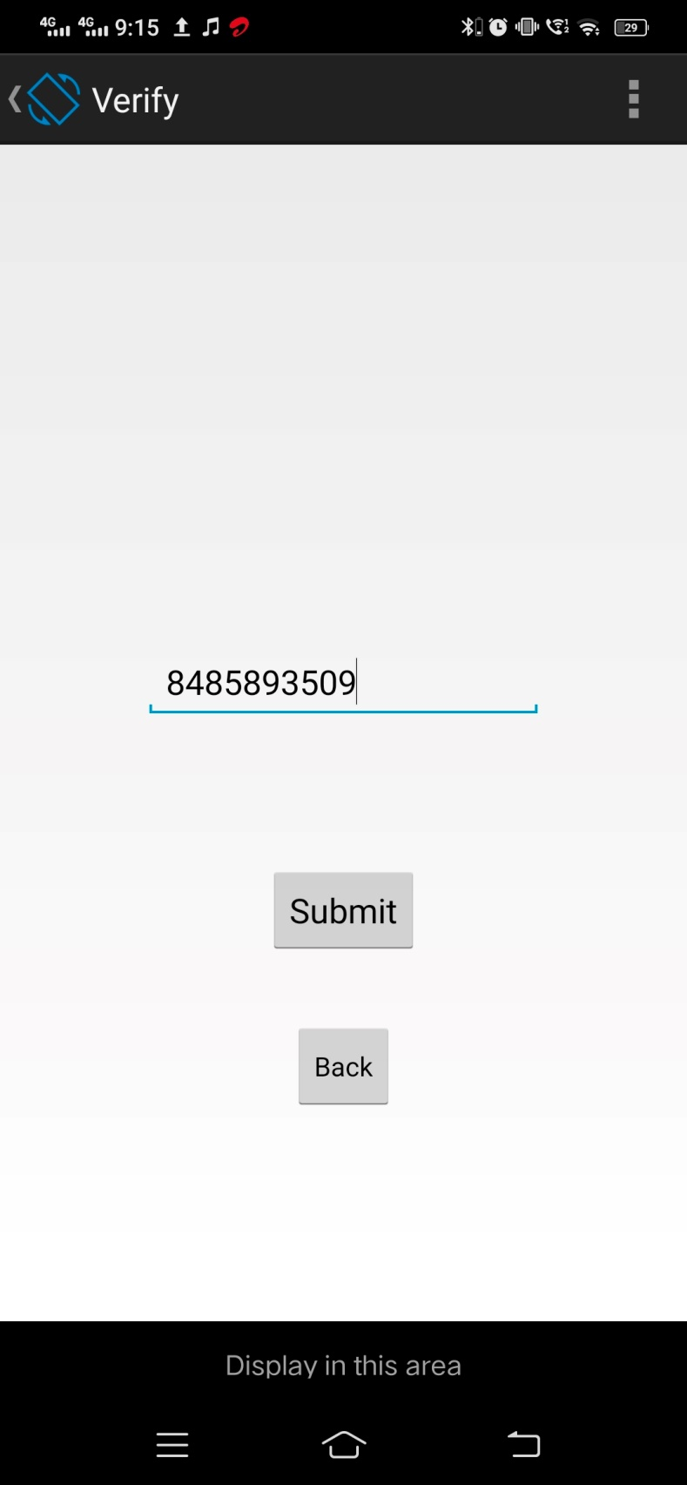

**Fig.Verify**

**Instructions Page**

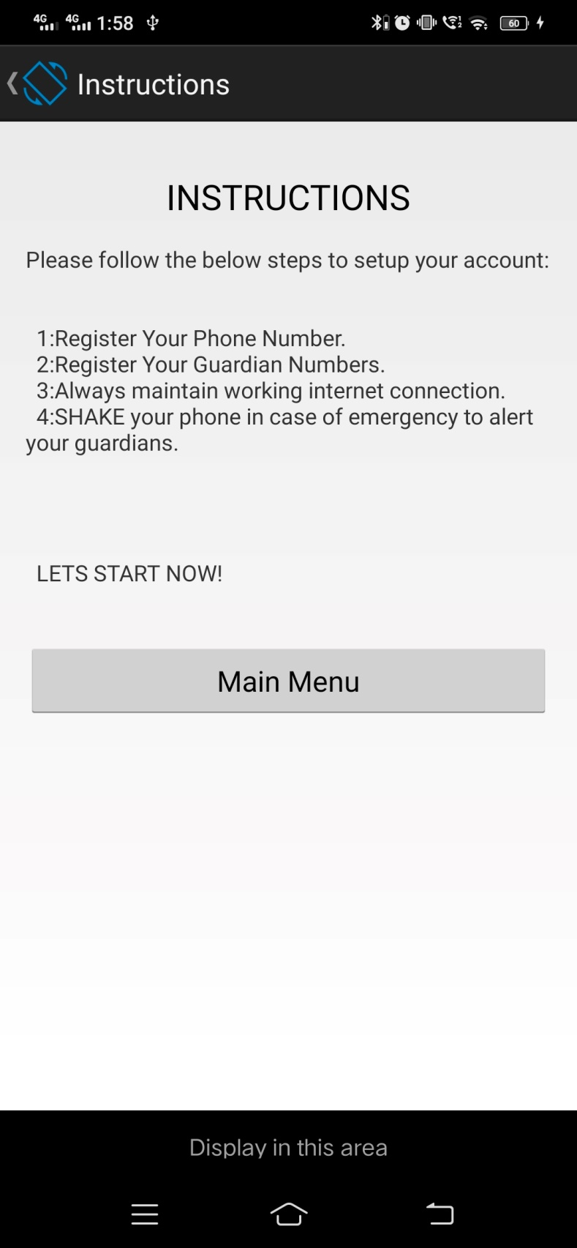

**Fig. Instruction**

**Display Page**

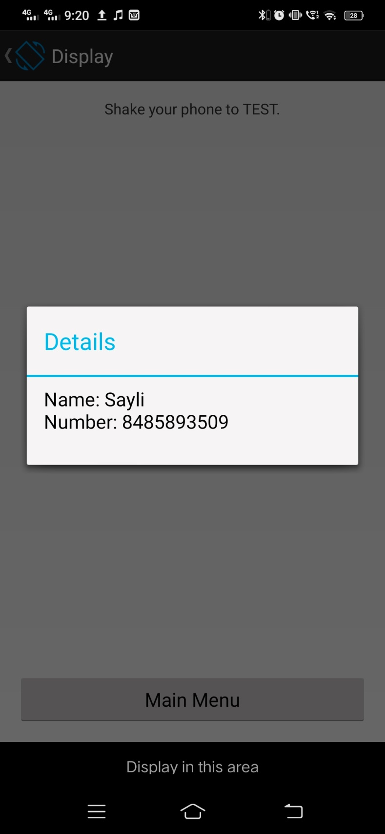

**Fig. Display**

* 1. **Skilled Developed/Learning Outcome of this Micro-Project:**

#### Practical Outcomes:

* + - * Understood current market strengths and weaknesses
      * Learned better planning, management, facilitation and execution of projects
      * Improved problem solving skills.

#### Unit Outcomes in Cognitive Domain:

* + - * Recalled or retrieved previous information.
      * Interpretation of instructions and problems.
      * Utilization of known concept in implementation
      * Troubleshoot small modules
      * Selection of the most effective solution

#### Outcomes in Affective Domain:

* + - * Awareness and willingness to listen others opinion
      * Improved presentation skills
      * Cooperation in group activities

### Scope of this Micro-Project:

As an independent nation, we must ensure respect and security of women and we cannot deny them this basic right. It is now time to initiate action to eradicate the menace of security issues with women. Violence against women remains embedded in our societies, both as a daily reality and a difficult situations .Gender justice is impossible in a world where at least one in three women faces violence in her lifetime, regardless of her culture, religion, socioeconomic class, or education level Our country can be a true democracy only when all women have the security and freedom from violence.

**Name & Signature of Course Teacher**

**(Prof. N.D.Dhamale)**

#### 

#### Annexure – IV

**Micro Project Evaluation Sheet**

**Name of Student:** Siddhesh Jagdish Shelar **Enrollment No:** 1711670171

**Name of Program:** Computer Engineering **Semester:** VI

**Course Title:** Mobile App Development **Course Code:** 22617

**Title of Micro Project:** Women Safety App

**Learning Outcomes Achieved:**

* + 1. Interprete features of Andriod operating system.
    2. Configure Android environment and development tools.
    3. Develop rich users Interfaces by using layouts and controls.
    4. Use User Interface components for android application development.
    5. Create Android application using database.
    6. Publish Android applications.

|  |  |  |  |  |  |  |
| --- | --- | --- | --- | --- | --- | --- |
| **Sr No** | **Characteristic to be Assessed** | **Poor**  **Marks (1-3)** | **Average**  **Marks (4-5)** | **Good**  **Marks (6-8)** | **Excellent**  **Marks (9-10)** | **Sub Total** |
| **(A) Process and Product Assessment (6 Marks)** | | | | | | |
| 1 | Relevance to the Course |  |  |  |  |  |
| 2 | Literature Review/Information Collection |  |  |  |  |
| 3 | Completion of the Target as per Project Proposal |  |  |  |  |
| 4 | Analysis of Data & Representation |  |  |  |  |
| 5 | Quality of Prototype/Model |  |  |  |  |
| 6 | Report Preparation |  |  |  |  |
| **(B) Individual Presentation/Viva (4 Marks)** | | | | | | |
| 7 | Presentation |  |  |  |  |  |
| 8 | Viva |  |  |  |  |

|  |  |  |
| --- | --- | --- |
| **(A)**  **Process and Product Assessment (6 Marks)** | **(B)**  **Individual Presentation/Viva (4 Marks)** | **Total Marks (10 Marks)** |
|  |  |  |

**Comments/Suggestions about Teamwork/Leadership/Inter-personal Communication (if any)**

#### …………………………………..……………………………………………………………………………

**Name & Designation of Course Teacher:** Prof. N.D Dhamale, Lecturer

Dated Signature:

**Annexure – IV**

**Micro Project Evaluation Sheet**

#### 

**Name of Student:**Jainual Jignesh Dave **Enrollment No:** 1611670124

**Name of Program:** Computer Engineering **Semester:** VI

**Course Title:** Mobile App Development **Course Code:** 22617

**Title of Micro Project:** Women Safety App

**Learning Outcomes Achieved:**

1. Interprete features of Andriod operating system.
2. Configure Android environment and development tools.
3. Develop rich users Interfaces by using layouts and controls.
4. Use User Interface components for android application development.
5. Create Android application using database.
6. Publish Android applications.

|  |  |  |  |  |  |  |
| --- | --- | --- | --- | --- | --- | --- |
| **Sr No** | **Characteristic to be Assessed** | **Poor**  **Marks (1-3)** | **Average**  **Marks (4-5)** | **Good**  **Marks (6-8)** | **Excellent**  **Marks (9-10)** | **Sub Total** |
| **(A) Process and Product Assessment (6 Marks)** | | | | | | |
| 1 | Relevance to the Course |  |  |  |  |  |
| 2 | Literature Review/Information Collection |  |  |  |  |
| 3 | Completion of the Target as per Project Proposal |  |  |  |  |
| 4 | Analysis of Data & Representation |  |  |  |  |
| 5 | Quality of Prototype/Model |  |  |  |  |
| 6 | Report Preparation |  |  |  |  |
| **(B) Individual Presentation/Viva (4 Marks)** | | | | | | |
| 7 | Presentation |  |  |  |  |  |
| 8 | Viva |  |  |  |  |

|  |  |  |
| --- | --- | --- |
| **(A)**  **Process and Product Assessment (6 Marks)** | **(B)**  **Individual Presentation/Viva (4 Marks)** | **Total Marks (10 Marks)** |
|  |  |  |

**Comments/Suggestions about Teamwork/Leadership/Inter-personal Communication (if any)**

#### …………………………………..……………………………………………………………………………

**Name & Designation of Course Teacher:** Prof. N.D. Dhamale, Lecturer

Dated Signature:

#### 

#### Annexure – IV

**Micro Project Evaluation Sheet**

**Name of Student:** Shreyash Kiran Dahale **Enrollment No:** 1711670155

**Name of Programme:** Computer Engineering **Semester:** V

**Course Title:** Mobile App Development **Course Code:** 22617

**Title of Micro Project:** Women Safety App

**Learning Outcomes Achieved:**

1. Interprete features of Andriod operating system.
2. Configure Android environment and development tools.
3. Develop rich users Interfaces by using layouts and controls.
4. Use User Interface components for android application development.
5. Create Android application using database.
6. Publish Android applications.

|  |  |  |  |  |  |  |
| --- | --- | --- | --- | --- | --- | --- |
| **Sr No** | **Characteristic to be Assessed** | **Poor**  **Marks (1-3)** | **Average**  **Marks (4-5)** | **Good**  **Marks (6-8)** | **Excellent**  **Marks (9-10)** | **Sub Total** |
| **(A) Process and Product Assessment (6 Marks)** | | | | | | |
| 1 | Relevance to the Course |  |  |  |  |  |
| 2 | Literature Review/Information Collection |  |  |  |  |
| 3 | Completion of the Target as per Project Proposal |  |  |  |  |
| 4 | Analysis of Data & Representation |  |  |  |  |
| 5 | Quality of Prototype/Model |  |  |  |  |
| 6 | Report Preparation |  |  |  |  |
| **(B) Individual Presentation/Viva (4 Marks)** | | | | | | |
| 7 | Presentation |  |  |  |  |  |
| 8 | Viva |  |  |  |  |

|  |  |  |
| --- | --- | --- |
| **(A)**  **Process and Product Assessment (6 Marks)** | **(B)**  **Individual Presentation/Viva (4 Marks)** | **Total Marks (10 Marks)** |
|  |  |  |

**Comments/Suggestions about Teamwork/Leadership/Inter-personal Communication (if any)**

#### …………………………………..……………………………………………………………………………

**Name & Designation of Course Teacher:** Prof. N.D. Dhamale, Lecturer

Dated Signature:

#### Annexure – IV

**Micro Project Evaluation Sheet**

**Name of Student:** Ojas Yogesh Joshi **Enrollment No:** 1811670507

**Name of Programme:** Computer Engineering **Semester:** V

**Course Title:** Mobile App Development **Course Code:** 22617

**Title of Micro Project:** Women Safety App

**Learning Outcomes Achieved:**

1. Interprete features of Andriod operating system.
2. Configure Android environment and development tools.
3. Develop rich users Interfaces by using layouts and controls.
4. Use User Interface components for android application development.
5. Create Android application using database.
6. Publish Android applications..

|  |  |  |  |  |  |  |
| --- | --- | --- | --- | --- | --- | --- |
| **Sr No** | **Characteristic to be Assessed** | **Poor**  **Marks (1-3)** | **Average**  **Marks (4-5)** | **Good**  **Marks (6-8)** | **Excellent**  **Marks (9-10)** | **Sub Total** |
| **(A) Process and Product Assessment (6 Marks)** | | | | | | |
| 1 | Relevance to the Course |  |  |  |  |  |
| 2 | Literature Review/Information Collection |  |  |  |  |
| 3 | Completion of the Target as per Project Proposal |  |  |  |  |
| 4 | Analysis of Data & Representation |  |  |  |  |
| 5 | Quality of Prototype/Model |  |  |  |  |
| 6 | Report Preparation |  |  |  |  |
| **(B) Individual Presentation/Viva (4 Marks)** | | | | | | |
| 7 | Presentation |  |  |  |  |  |
| 8 | Viva |  |  |  |  |

|  |  |  |
| --- | --- | --- |
| **(A)**  **Process and Product Assessment (6 Marks)** | **(B)**  **Individual Presentation/Viva (4 Marks)** | **Total Marks (10 Marks)** |
|  |  |  |

**Comments/Suggestions about Teamwork/Leadership/Inter-personal Communication (if any)**

#### …………………………………..……………………………………………………………………………

**Name & Designation of Course Teacher:** Prof. N.D. Dhamale, Lecturer

Dated Signature:



## Maharashtra State Board of Technical Education

**Certificate**

This is to certify that **Mr. Jainul Jignesh Dave** with **Roll No- 01** has successfully completed Micro-project in course **Mobile App Development (22617)** for the academic year 2021-22 as prescribed in the 'Assessment Manual' during his/her tenure of completing Fifth Semester of Diploma Program in Computer Engineering from institute, Sandip Polytechnic with institute code 1167.

**Place:** Nashik **Enrollment No:** 1711670120

#### Date: //2021 Exam Seat No:

**Course Teacher Head of the Department Head of the Institute**



## Maharashtra State Board of Technical Education

**Certificate**

This is to certify that **Mr. Shreyash Kiran Dahale** with **Roll No- 08** has successfully completed Micro-project in course **Mobile App Development (22617)** for the academic year 2021-22 as prescribed in the 'Assessment Manual' during his/her tenure of completing Fifth Semester of Diploma Program in Computer Engineering from institute, Sandip Polytechnic with institute code 1167.

**Place:** Nashik **Enrollment No:** 1711670155

#### Date: //2021 Exam Seat No:

**Course Teacher Head of the Department Head of the Institute**



## Maharashtra State Board of Technical Education

**Certificate**

This is to certify that **Mr. Ojas Yogesh Joshi** with **Roll No- 57** has successfully completed Micro-project in course **Mobile App Development (22617)** for the academic year 2021-22 as prescribed in the 'Assessment Manual' during his/her tenure of completing Fifth Semester of Diploma Program in Computer Engineering from institute, Sandip Polytechnic with institute code 1167.

**Place:** Nashik **Enrollment No:** 1611670156

#### Date: //2021 Exam Seat No:

**Course Teacher Head of the Department Head of the Institute**